Desk Number ________

Student Number _______________________

Student Name _______________________

**School of Science and Engineering**

**FINAL EXAMINATION**

Semester 1, 2017

**CSC1001 Introduction to Computer Science**

Examination Duration: 120 minutes

Reading Time: 10 minutes

This examination has __3__ questions.

**Exam Conditions:**

This is a FORMAL Examination

This is a RESTRICTED OPEN BOOK Exam. Maximum of one (1) sheet of handwritten notes double sided are permitted

**Materials Permitted In The Exam Venue:**

Maximum of one (1) sheet of handwritten notes double sided are permitted. **NO OTHER MATERIALS PERMITTED**

Any calculators without the functionalities of programming and file storage are permitted.

**Materials To Be Supplied To Students:**

1 × 12 Page Answer Booklet

Question 1. (15 × 2% = 30%)

Pick the correct option in each of the following sub-questions. Note that only ONE option is correct.

* 1. Binary number 1101111.111 and hexadecimal number 2AC.3 equal to decimal numbers:

1. 111.875 and 684.1875
2. 110.85 and 683.1875
3. 111.111 and 684.3
4. 110.85 and 683.3
   1. Concerning Python language, which of the following statements is incorrect?
5. Python uses an interpreter to translate source codes into machine codes.
6. In Python, reserved words cannot be used as variable names.
7. In Python, a variable has a fixed location in the memory.
8. true and false are not reserved words in Python.
   1. Concerning the following program, which of the following statements is incorrect?

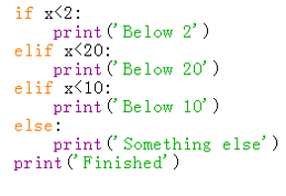

1. print(‘Below 2’) will be executed when $x=1$.
2. print(‘Below 20’) will be executed when $x=10$.
3. print(‘Below 10’) will be executed when $x=8$.
4. print(‘Something else’) will be executed when $x=20$.
   1. Concerning the object in Python, which of the following statements is incorrect?
5. Every object in Python has a unique ID.
6. The type of an object is determined automatically by Python interpreter according to its value.
7. Every variable is essentially a reference to an object.
8. The ID of an object may be changed during the execution of the program.
   1. Concerning the class in Python, which of the following statements is incorrect?
9. A class is a template for creating objects in Python.
10. We can create many different objects from the same class.
11. In a class, variables and functions are also called data fields and methods.
12. If two objects are created from the same class, they will always contain identical data fields.
    1. Concerning the following program, which of the following statements is incorrect?

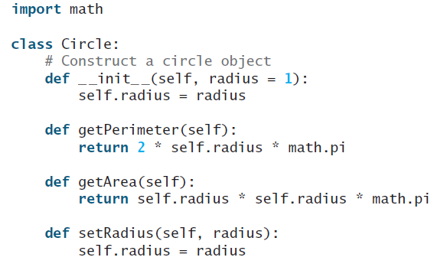

1. The purpose of __init__() is to initialize the data fields in class Circle().
2. Class Circle() contains only 4 methods.
3. In method getPerimeter(), self is a reference pointing to the object from which getPerimeter() is invoked.
4. When creating an object from class Circle(), it is acceptable to input 0 arguments.
   1. Concerning the following program, which of the following statements is incorrect?

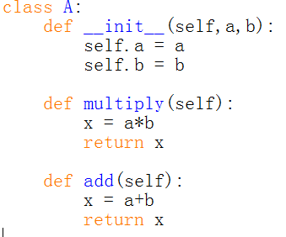

1. Class A() contains two newly defined data fields.
2. The scope of self is throughout the whole body of class A().
3. Method add() will return the sum of two data fields a and b.
4. Variable x defined in multiply() and add() are two different local variables.
   1. Concerning the following two programs, which of the following statements is incorrect?

|  |  |
| --- | --- |
|  |  |

1. When executing the first program, an error will be triggered.
2. When executing the second program, an error will be triggered.
3. The first class A() will inherit the initializer from its parent class.
4. The a.setRadius(3) statement of the second program aims to set the radius of a to 3.
   1. Concerning private members of a class, which of the following statements is incorrect?
5. In Python, the names of private data fields and private methods start with 2 underscores and do not end with 2 underscores.
6. Private data fields can be accessed within a class.
7. Private methods can be directly accessed outside the class definition.
8. Private data fields are defined to prevent potential data corruption.
   1. Concerning class inheritance in Python, which of the following statements is incorrect?
9. Inheritance enables you to define a special class and later extend it to define more general classes.
10. A subclass may inherit data fields and methods from its superclass.
11. When defining a subclass, the name of its superclass should be placed in the parenthesis after the name of the subclass.
12. In Python, every user-defined class is essentially a subclass of other classes.
    1. Concerning tuple, which of the following statement is correct?
13. A tuple is a sequence of elements which are indexed from 1.
14. The content of a tuple can be changed during the runtime.
15. Tuple is more efficient compared with list in Python.
16. Tuples are comparable and two tuples are equal if their first elements are equal.
    1. Concerning the following program, which of the following statements is incorrect?

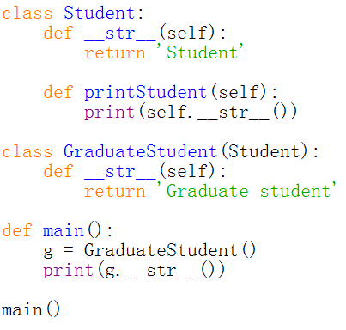

1. The output of this program is ‘Student’.
2. Class GraduateStudent() has inherited the method printStudent().
3. Method __str__() has been overridden in class GraduateStudent().
4. In class GraduateStudent(), method printStudent() will be inherited from class Student().
   1. Concerning the following program, which of the following statements is correct?

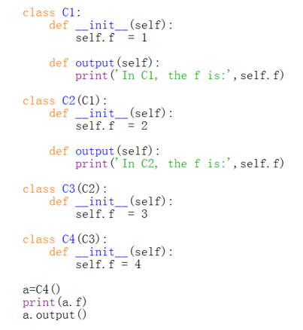

1. On the inheritance chain defined in this program, class C1() is the highest class.
2. In this program, the output() method defined in class C2() will be executed.
3. When running this program, an error will be triggered.
4. The output of this program is:

4

In C2, the f is: 2

* 1. Concerning data structure and algorithm, which of the following statements is incorrect?

1. Data structure concerns how to organize and access data.
2. An algorithm is a step-by-step procedure for performing some task in a finite amount of time.
3. The quality of an algorithm can be determined by measuring its running time only.
4. When analysing the running time of an algorithm, two commonly used approaches are experimental analysis and asymptotic analysis.
   1. Concerning algorithm analysis, which of the following statements is incorrect?
5. In algorithm analysis, we focus on the growth rate of the running time as a function of the input size.
6. The result of asymptotic analysis is platform dependent.
7. An algorithm with a time complexity of O($n$) will always perform better than an algorithm with a time complexity of O($2^{n}$).
8. A polynomial time algorithm is usually considered as tractable.

Question 2. (10 × 4% = 40%)

Pick the correct option/s in each of the following sub-questions. Note that there may be MULTIPLE correct options for each sub-question.

* 1. Concerning the following program, which of the following statement/s is/are correct?

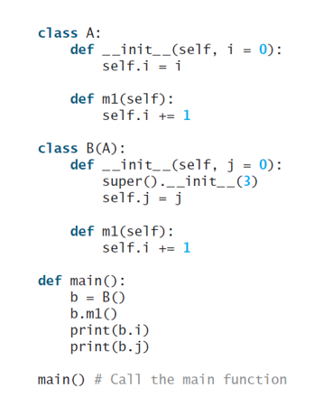

1. Class B() has only one super class.
2. In class B(), the initializer of A() is accessed by calling function super().
3. Class B() has only one data field.
4. When running this program, an error will be triggered.
   1. Concerning the following program, which of the following statement/s is/are correct?

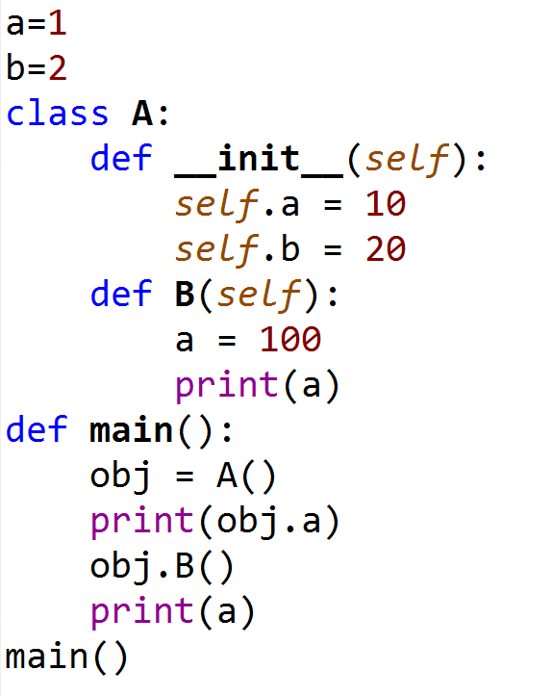

1. In this program, three different variables a have been defined.
2. Data field a of class A() can only be accessed within the class definition.
3. The value of global variable a will initially be set as 1, and then changed to 100.
4. The output of this program is

10

100

100

* 1. Concerning the following two programs, which of the following statement/s is/are correct?

|  |  |
| --- | --- |
|  |  |

1. The output of the first program is:

Person

Student

1. The output of the second program is:

Person

Student

1. In the first program, the getInfo() method will be overridden in class Student().
2. In the second program, the __getInfo() method will be overridden in class Student().
   1. Concerning algorithm analysis, which of the following statement/s is/are correct?
3. The big-Oh notation allows us to say that a function f(n) is always less than or equal to another function g(n) up to a constant factor.
4. The big-Oh notation is usually used to characterize the running time of an algorithm in the asymptotic sense.
5. Function $5n^{4}+6n^{3}+2n^{2}+2^{n}+2n$ is O($n^{4}$).
6. When we analyse an algorithm, we are usually interested at its average performance regardless of the input size.
   1. Concerning recursion, which of the following statement/s is/are correct?
7. Recursion is a programming technique by which a function makes one or more calls to itself during execution.
8. To write a recursion program, we usually need to define the problem in a recursive way first.
9. If a recursive function is designed so that each invocation of the body makes at most one new recursive call, it is called a linear recursive function.
10. If a recursive function may make more than one recursive calls, it is called a multiple recursive function.
    1. Concerning the binary search algorithm, which of the following statement/s is/are correct?
11. The purpose of this algorithm is to find out whether a target element exists in a given sequence of elements.
12. Binary search algorithm can be applied on an unsorted sequence.
13. The time complexity of binary search is O(log n).
14. Binary search is usually more efficient than sequential search.
    1. Concerning stack, which of the following statement/s is/are correct?
15. A stack can be accessed based on the “last in first out” principle.
16. More than one elements of a stack can be accessed simultaneously if necessary.
17. The time complexity of Inserting an element into a stack is linear.
18. The time complexity of removing an element from a stack is constant.
    1. Concerning queue, which of the following statement/s is/are correct?
19. Data are saved sequentially in a queue.
20. Data can only be removed from the tail of a queue.
21. Data can only be inserted at the head of a queue.
22. A queue can only be implemented based on a list.
    1. Concerning linked list, which of the following statement/s is/are correct?
23. We can identify the tail of a singly linked list as the node having None as its next reference.
24. The time complexity of inserting a node at the tail of a linked list is constant.
25. The time complexity of removing a node at the tail of a linked list is constant.
26. Every node in a doubly linked list contains at least two references.
    1. Concerning a binary tree, which of the following statement/s is/are correct?
27. In a binary tree, data are saved hierarchically.
28. In a non-empty binary tree, there is only one node which has no parent.
29. Every node on a binary tree contains at least three references.
30. In a binary tree, every node has zero or two child nodes.

Question 3. (5% + 5% + 7% + 5% + 8% = 30%)

Answer the following questions.

* 1. Concerning the following program

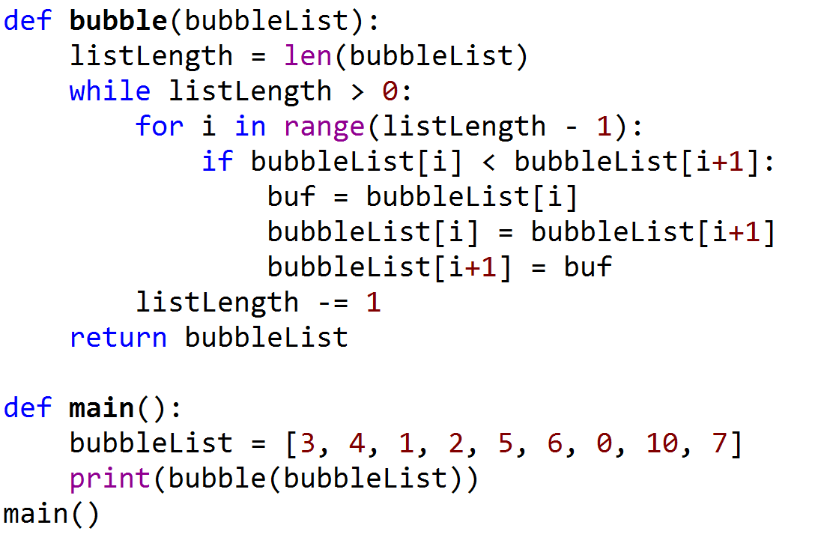

Answer the following questions:

1. What are the outputs of this program?
2. Which sorting algorithm is applied in this program?
3. What is the time complexity of this sorting algorithm? How do we prove this?
   1. Concerning the following program

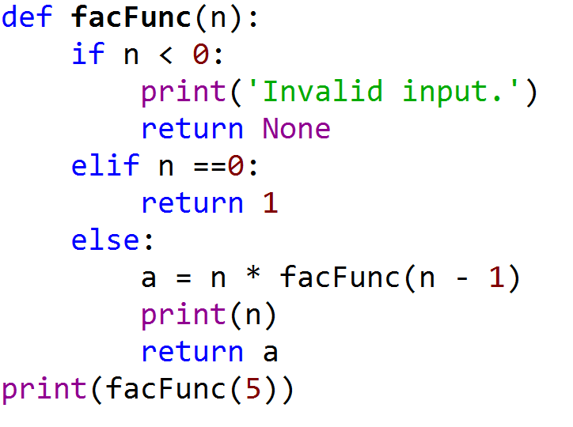

Answer the following questions:

1. This program is used to calculate which function?
2. Write down the corresponding recursive definition of this program.
3. How many times function facFunc() will be called in total and write down the output.
   1. Write a function which takes two inputs x and n, and outputs . This function should be a recursive function and have a time complexity of O(log n).
   2. Concerning the following program, and assume that input t will be a reference pointing to the root of a binary tree.

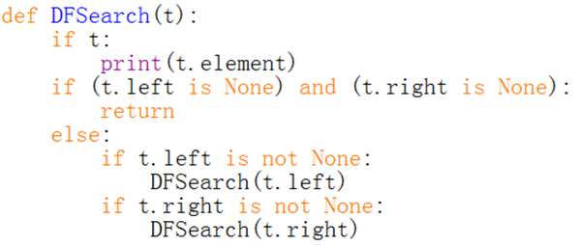

Answer the following questions:

1. Which algorithm is implemented in this function?
2. What is the time complexity of this algorithm?
3. Is this function a linear recursive or multiple recursive function?
4. If input t is referencing to the root of the following tree, what would be the outputs of this function?

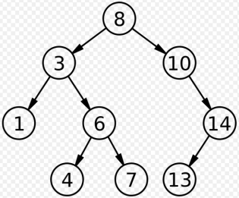

* 1. Answer the following two questions:

A. Write a function, which takes a variable t as the input. Input argument t will be a reference pointing to the root of a binary tree. This function should use a Breadth First Search algorithm to print out the values of all nodes on this binary tree.

B. If input t is referencing to the root of the binary tree shown in question 3.4, what would be the outputs of your function?

**END OF EXAMINATION**